Parametric Processes and Applications with Specialty Optical Fibers

Leily S. Kiani

Ph.D. Student, Physics and Chemistry Group

School of Natural Sciences

University of California, Merced

5200 N. Lake Rd. Merced, CA 95343

Email: lkiani@ucmerced.edu

Graduate Advisor

Jay E. Sharping

Associate Professor, School of Natural Sciences

University of California, Merced

5200 N. Lake Rd. Merced, CA 95343

Email: [jsharping@ucmerced.edu](mailto:jsharping@ucmerced.edu)

Ph.D Qualifying Exam Proposal

July 30, 2012

Contents

1. Proposal Summary……………………………………………………………………...…2
2. Motivation………………………………………………………………………………....2
3. Hypothesis………………...…………………………………………………………........2
4. Background………………………………………………………………………..............2

*4.1 Microstructure Optical Fibers*...........................................................................….....3

* 1. *Nonlinearity and Four-Wave Mixing and Fiber Optical Parametric Oscillators*…...4

1. Specific Aims…………………………………………………………………………...…6
   1. *Specific Aim #1*……………………………....……………………………………6
      1. *Preliminary data specific aim #1*…………………………………7
   2. *Specific Aim #2*………………………………………...…………………………….7
      1. *Preliminary data specific aim #2*…………………………………7
   3. *Specific Aim #3*……………..……………………………..……..……………………9
      1. *Preliminary data specific aim #3*……………………….…………9
2. Research Plan………………………………………………………………………….....10
3. Timeline …………………………………………………...……………………….........13
4. References…………………………………………………….…………………….........14
5. Proposal Objectives

The overall objectives of this proposed project are to (1) use a directly modulated light source to explore third order nonlinearity in two soft-glass microstructure optical fibers (SG MOF) (2) quantify key characteristics of these fibers and (3) utilize a suitable SG MOF for parametric generation and amplification in the region of 1.6µm.The proposed studies will elucidate the quality of nonlinearity in these novel optical fibers. This information will help us to address the challenges we have observed thus far implementing a microstructure optical fiber with the hexagonal wagon-wheel design in parametric gain experiments. Results of this study will provide a parameter framework on which to develop fiber optical parametric oscillators (FOPOs) with SG MOFs.

1. Motivation

Coherent light is a fundamental scientific tool. The advent of coherent light sources via laser technology has shaped modern scientific measurement methods. The utility of laser light sources has immense reach into many sectors of the modern economy; streaming video content over the internet would not be possible without the speed of optical communication technology. Every application of coherent light warrants some tailoring of the source properties, particularly wavelength. For example, the wavelengths at which optical communication signals operate are limited by the medium through which they are transmitted. Even though a great deal of effort has been exerted to generate laser sources for a variety of wavelengths to address these challenges, applications require an ever greater range of source spectrum. Alternative coherent light generation methods exist for many areas of spectrum through exploitation of nonlinear optical phenomena.

The study of high intensity laser light and material interactions is the basis of the field of nonlinear optics. These interactions can be used to increase the range of accessible spectrum. This idea was pioneered by Franken et. al. in the demonstration of second harmonic generation in quartz crystal [1]. In fact, any dielectric material becomes a nonlinear with high enough optical field strength so the class of materials that serve for this application is not limited to crystals. Glass fibers exhibit nonlinearity with the transmission of light of high optical field strength.

1. Hypothesis

The capability to modify overall nonlinearity by implementing a microstructure in optical fiber leads to notably high nonlinear coefficients *and* simultaneously manages dispersion. This extreme nonlinearity can be utilized for commercially viable coherent source development. **Nonlinearity in hexagonal wagon wheel microstructure optical fibers is either (1) well suited for parametric frequency generation with relatively low input pulse power or (2) better suited for efficient supercontinuum generation.**

1. Background

Study of nonlinear fiber optics began with the advent of low-loss silica fibers in the 1970’s, when fiber loss came down to 0.2 dB/km [2]. A suite of nonlinear scattering process like Raman and Brillouin scattering in addition to other nonlinear effects like self-phase modulation (SPM) and four-wave mixing (FWM) could be studied in these fibers. These processes were utilized to generate waveforms of interest, namely, optical solitons and ultrashort pulses. The addition of rare-earth dopants (erbium, ytterbium) allowed for optical fiber based light amplification. More recently amplification via stimulated Raman scattering and FWM, two amplification techniques that do not require the use of dopants, have become attractive because amplification is possible in any spectral region. FWM is especially attractive because the ultrafast regime is accessible by this amplification process [3].

In the 1990’s, varied fiber structures with small mode confinement diameters were explored to increase the nonlinearity and manage dispersion. The nonlinear parameter γ can be written,



where  is the nonlinear refractive index,  is the wavelength and  is the effective mode area (core size) [2].This shows that the nonlinearity is inversely proportional to the core size. However it is important to note that losses increase as the core size becomes smaller so a tradeoff exists between the nonlinear parameter  and the losses due to confinement. Many variations in fiber designs are being explored to push the envelope of achievable nonlinearity while maintaining practicality of fiber fabrication and implementation [4, 5, 6].

* 1. *Microstructure Optical Fibers*

One variant is referred to as microstructure optical fiber (MOF). MOFs do not have a core and cladding of differing dielectric materials but rather generate an effective guided area by a radial pattern of air holes about a solid core in a single type of glass. The air holes contribute to an overall lower refractive index like a cladding layer. The microstructure can be formed in the fiber through extrusion. The process mainly is in two steps wherein molten glass is forced through a die to create a large version of the fiber structure called a preform then the preform is tapered down a number of times to obtain the proper core size. Varied glass types and dopants can be used to raise the nonlinear refractive index and thus the nonlinearity parameter γ.

For nonlinear optical applications in these fibers, it is essential to be able to generate a suite of properties in the fiber by defining the glass type and the microstructure. High nonlinearity, low-loss and fine control over dispersion are the primary properties that a fabricator is interested in designing. High nonlinearity is achieved in MOFs by creating a tight mode confinement with a small core size and thus a high numerical aperture [4]. Simultaneously, the dispersion and losses need to be managed by controlling the glass-air ratio.

Guided light is confined to a fiber’s core because of a refractive index difference at the boundary of the core and cladding. For MOFs, which are composed of a single material with a single refractive index, the field is confined to an effective core which partially extends into the air-hole region. The transverse field envelope determines the effective core and cladding boundary. The glass-air ratio in the region around the core is considered in the calculation of the effective cladding index. A measure of this ratio is the ratio of air-hole diameter *d* and the hole-to-hole spacing. Larger diameters and more tightly spaced holes reduce the effective cladding index resulting in a tighter mode confinement [2]. For a fixed, an effective cladding index can be numerically determined as a function of wavelength. Pictured at left is a microstructure referred to as hexagonal lattice. **Numerous microstructure designs can be postulated to vary the mode confinement and thus the fiber properties.**

Figure 1: schematic of Microstructure optical fiber [7].



The MOF dispersion parameter can shift a great deal with a relatively small change in the ratio [7]. An overall MOF’s dispersion can vary greatly from the dispersion of the glass composition [4]. The figure below shows a measure of dispersion parameter, D, for a MOF made from a glass with a markedly different dispersion behavior. It shows that the zero dispersion wavelength (ZDW) can be shifted by the addition of microstructure. The ability to control the ZDW of these fibers is essential for FOPO operation in many regions of spectrum. An ideal fiber for dramatic exhibition of nonlinear effects would have high nonlinearity and low dispersion in the pumping region. Since small changes in the microstructure can result in such varied dispersion profiles [4], the potential for various MOF and pump laser combinations is galvanizing. However current fabrication methods face challenges that jeopardize sufficient homogeneity in the microstructure for such well-defined dispersion tailoring.



Figure 2: Shows dispersion parameter D for an SF57 SG MOF of two different core sizes [Petropoulos]. Note: the material dispersion for SF57 glass is zero near 2um. Here the microstructure blue shifts the ZDW by nearly 700nm.

Efforts to push the limits of nonlinearity in optical fibers have motivated a new design approach for microstructure optical fibers. The addition of highly nonlinear material to the fiber design has resulted in fibers with many orders of magnitude higher nonlinearity than standard optical fibers [4,5,6]. Non-Silica glasses can exhibit high nonlinearity and reasonable structural properties to merit their use in MOFs. These glasses include chalcogenide, tellurite, and the so-called “soft-glasses”, lead silicate glasses like SF57 (Schott), and bismuth oxide glass (Bi2O3) [2]. **The highly tailorable properties of soft glass microstructure optical fibers are attractive for use in fiber based optical parametric oscillatiors.**

* 1. *Nonlinearity and Four-Wave Mixing and Fiber Optical Parametric Oscillators*

Fiber optical parametric oscillators (FOPOs) are devices designed to amplify a four-wave mixing process in a fiber. Four-wave mixing is a third order, four frequency light wave interaction in nonlinear material. Sum and difference frequencies between the four fields are generated with phase matching dependent energy transfer. The phase matching requirement necessitates a judicious choice of input wavelength, one that matches a fiber’s dispersion parameters (i.e. the zero dispersion wavelength).

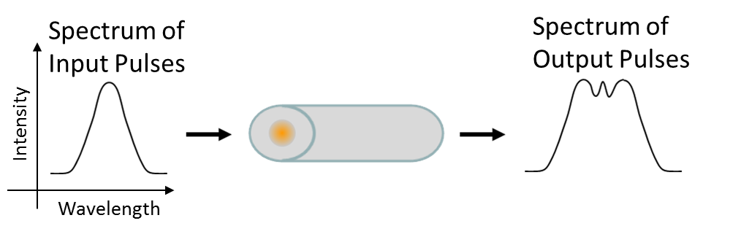In order to develop a scheme for FOPO design with a soft-glass microstructure optical fiber it is also necessary to estimate the nonlinear parameter  at the pumping wavelength. A test of self-phase modulation (SPM) is a suitable diagnostic for nonlinearity. The experiment can be done by launching high-power pulses into a fiber of sufficient length for nonlinearity and viewing the output spectrum.

The nonlinear phase shift is defined as,

Figure 3: Schematic of nonlinear phase shift measurement. Pulses are simply launched into a segment of fiber and the intensity dependent broadening due to self-phase modulation is observed [8].



Where is the peak power of the injected pulse and is the nonlinear length of the fiber [2]. Phase shift is evident in the measured output spectrum so $γ$ can be inferred from this relationship. Establishing an estimate for the nonlinearity and the zero dispersion wavelength is critical for determining if a fiber will be inclined to exhibit pronounced four-wave mixing (FWM).

FWM is a third order or  parametric process. The third order induced polarization of a dielectric is given as,



where  is the third order susceptibility of the medium and is the electric field [2]. In the case of four waves interacting, the total induced polarization will have many terms involving products of the four electric fields and the relative phases between them. This will yield intensity dependent sum and difference terms to the total polarization of the material. The experimental result is spectral peaks that form symmetrically about the input wavelength referred to as side bands. The FWM sidebands can be understood to be a Stokes and an Anti-Stokes shifted peak. The two peaks are known as signal and idler ( and respectively) will satisfy the following condition,



which basically states a conservation of energy relationship between the scattered and pump wavelengths. The quantum mechanical picture of the FWM process corresponds to the case where two photons of frequencies and  annihilate while two photons and are generated simultaneously.

This process is one of a class of process referred to as parametric, as they depend on the medium parameters. For parametric processes to experience gain, the optical waves involved must be phase matched in their propagation along the fiber. This is especially true for FWM which requires phase matching of optical frequencies and wave vectors [2].

Experimentally, phase matching requires that the FWM process be pumped at a wavelength where the sidebands have the same group velocity dispersion. This wavelength is the zero dispersion wavelength of the fiber and the sidebands are generated symmetrically about this pump wavelength. Microstructure optical fibers have been employed in FWM experiments since the early 2000’s [11, 12, 13, 14]. One added feature of using a MOF for four-wave mixing is that the fibers can have a complex phase matching landscape. Multiple zero dispersion wavelengths, higher orders of dispersion and polarization dependent birefringence can be used to modify the phase matching landscape [2]. Placing this fiber in an oscillation cavity can then add tunablity to the FWM process.

1. Specific Aims

Input pump laser stability plays a large role in proper operation for fiber optical parametric oscillators. Preliminary experiments with two (2) types of input lasers have shown inconclusive results. Colleagues at the Institute for Photonics and Advanced Sensing (**IPAS**) at the University of Adelaide, Australia have obtained interesting results with a stable mode-locked fiber laser. Future experiments will focus on achieving four-wave mixing (FWM) with stable, easy to use pump lasers.

**5.1 Specific Aim #1: Build a directly modulated tunable (DMT) pump laser that can achieve a peak power sufficient for a FOPO device.**

Nonlinear fiber optical experiments generally require peak powers on the order of kW. In order to avoid damaging the fiber, these high peak powers are achieved with extremely short pulse durations. Fiber-based OPOs have predominantly utilized mode-locked lasers that supply pulses as short as hundreds of femtoseconds. These lasers are difficult to use and unrealistic for commercialization of FOPOs. We propose to develop a directly modulated, continuous wave source with the capacity to pump FOPO devices. In order to achieve the appropriate powers and pulse durations, a number of amplifiers and modulated source combinations will be studied. This study will determine the required parameters for the directly modulated FOPO pump laser.

*5.1.1 Preliminary data for Specific Aim #1*

We have achieved pulses as short as 2.5ns by modulation of a continuous wave laser tunable from 0.98µm to 1.09µm (TOptical DLpro). These pulses are amplified by a ytterbium doped fiber amplifier (YDFA) and injected into 40m of Hi1060 optical fiber. No significant nonlinear phase shift has been observed but we aim to generate higher pulse peak powers by modulating to achieve shorter pulse durations and by applying greater amplification.

**5.2 Specific Aim #2: Perform fiber characterization experiments with directly modulated tunable Erbium-doped fiber laser.**

Many preliminary experiments have been performed on the soft glass microstructure optical fibers (SGMOFs) to determine their relevant characteristics. The measurement of chief importance is of the dispersion in this fiber around the intended pumping region. The FOPO pumping region is chosen for phase matching conditions and the location of zero dispersion is critical knowledge. These SGMOFS are predicted to have zero dispersion in the region near 1.6µm. A directly modulated and amplified tunable Erbium doped fiber laser will be used to pump in this region.

The stable fiber-laser source will allow for an estimate of the nonlinearity parameter that is more precise than any measurement we have made before. An accurate peak number in the spectrogram of a SPM experiment can yield a reasonable estimate for the fiber nonlinearity. The purity of this new source will help avoid getting spurious peaks in the spectral results.

*5.2.1 Preliminary data for Specific Aim #2*

We have obtained two (2) microstructure optical fibers fabricated using extrusion methods. These fibers have been particularly interesting for study in the near infrared (NIR) region. This region is interesting for biophotonics applications. Experiments thus far have focused on a particular fiber we refer to here as the SF57 hexagonal wagon wheel (SF57 HWW) fiber.

The microstructure in this fiber was designed using a novel method for predicting specific fiber parameters [5]. This method couples a genetic algorithm with beam propagation calculations. An optimal microstructure design was determined for achieving high nonlinearity and low dispersion in the near infrared range, near 1.6µm. A drawing of this microstructure and an SEM image of the resulting microstructure from fabrication are pictured on the following page.

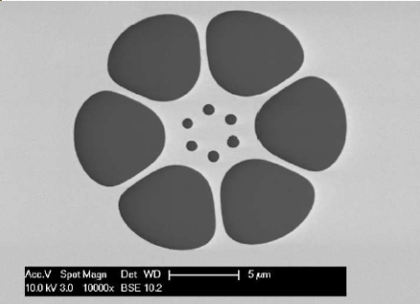

Figure 4: Left, drawing depicting the designed fiber core microstructure; Right, SEM image of the fabricated core. [5]

*Dispersion*

The frequency dependence of the refractive index in a fiber is a consequence of chromatic dispersion [2]. Dispersion in fibers can differ from the bulk material dispersion. Understanding of a fiber’s dispersion profile is critical information for experimental designs that utilize short, high bandwidth pulses.

We have performed preliminary experiments to measure this fiber’s zero dispersion wavelength (ZDW) using Fourier transform spectral interferometry (FTSI) [9, 10]. In this measurement, the fiber is placed in one arm of a Michelson interferometer and the Fourier transform of the spectral interferogram is measured for a range of wavelengths. Once calibrated, the peak value of the Fourier transform for each wavelength quantifies the temporal delay that the fiber imparts to the pulses relative to the free space propagation. The derivative of this delay curve yields the group velocity dispersion curve for this fiber. A theoretical dispersion profile can be calculated from an image of the fabricated fiber’s microstructure. The dispersion in this fiber has been theoretically calculated to have zero dispersion near 1.6µm [15].

Our best data for dispersion is taken using a high power OPO tunable from 1.3µm to nearly 1.6µm (Coherent MIRA HP, APE-OPO). Plots of the predicted and measured dispersion of the SF57 HWW mcrostructure fiber are shown below.

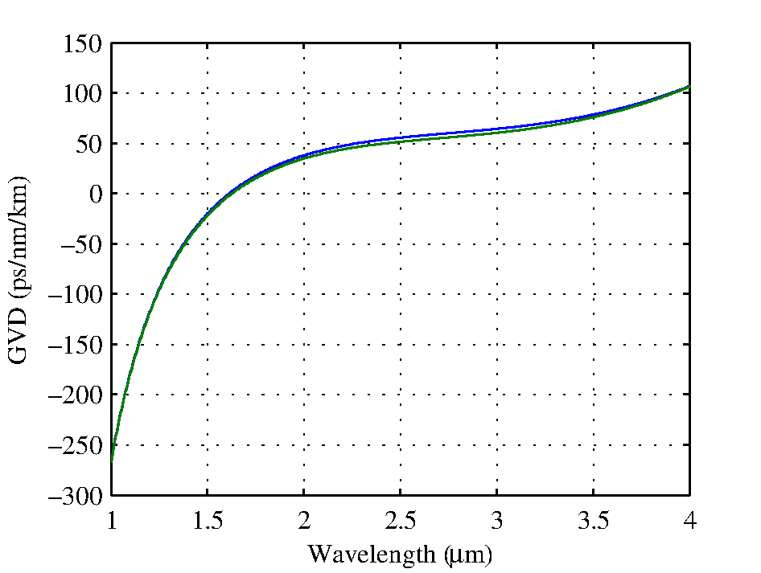

Figure 5: Left, calculated group velocity dispersion for the fabricated SF57 HWW fiber (blue and green lines represent slightly different core sizes) [15] Right, measured and calculated group velocity dispersion showing similar zero dispersion wavelengths in the region near 1.6µm..

The measured dispersion near the ZDW differs from the calculated dispersion by an approximate factor of two (2). The source of this difference is unclear; it is possible that a calibration errors or source instability contribute to the discrepancy. An improved characterization of dispersion for the SF57 HWW fiber warrants a stable source tunable in the region of the zero dispersion wavelength. We propose to do additional experiments utilizing a source developed from the study in specific aim #1.

**5.3 Specific Aim #3: Attempt a FOPO with DMT source and two highly nonlinear optical fibers.**

In order to steer this technology toward commercial availability we hope to build a fiber optical parametric oscillator with a directly modulated tunable (DMT) pump laser. The significance of the shift from pumping with a mode-locked laser is that the stability and usability is far superior in the DMT pump laser. The DMT pump is limited in the capability to produce ultrashort pulses. Pulses from the mode-locked laser sources can be several orders of magnitude shorter and achieve several orders of magnitude higher peak powers. The heightened peak power in the source allows for much higher nonlinearity when launched into a fiber. Because these fibers have such high theoretical nonlinearity we believe that when utilized properly, the DMT source can provide sufficient peak power for nonlinear processes. The result will demonstrate the achievability of a coherent light source with sufficient range, brightness and usability for commercialization.

*5.3.1 Preliminary Data for Specific Aim # 3*

*Nonlinearity and Four-Wave Mixing*

An estimate of the nonlinearity is critical for determining if a fiber will be suitable for parametric amplification. The parametric process we are most interested in generating in this fibers is four-wave mixing, a third order,, parametric process. In the case of four waves interacting, the total induced polarization will have many terms involving products of the four electric fields and the relative phases between them. New optical frequencies are gained in this process. The quantum mechanical picture of the FWM process corresponds to the case where two photons of frequencies and  annihilate while two photons and are generated simultaneously.

We have attempted to observe spontaneous FWM by injecting 200fs pulses from a mode-locked Ti:Sapphire laser tunable in the range from 1.1um to 1.6um. Pronounced broadening due to self-phase modulation however no indicators of FWM were shown for unaltered inputs from this source. Results are shown on the following page.

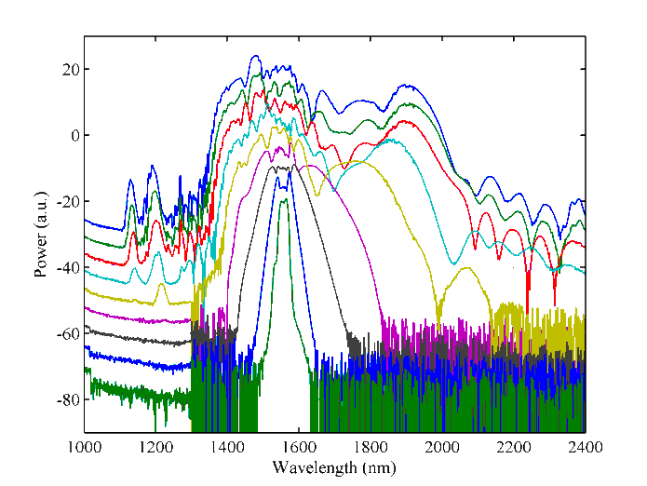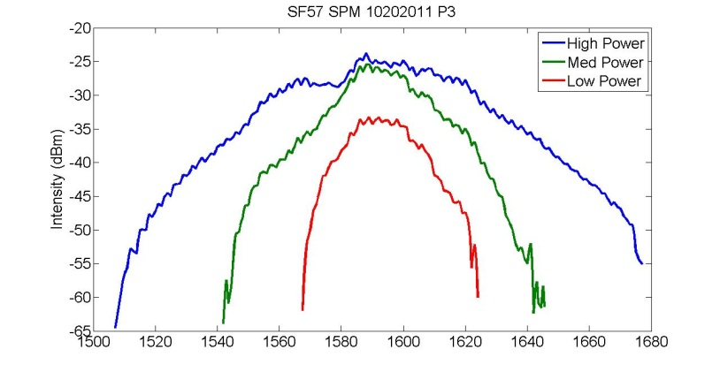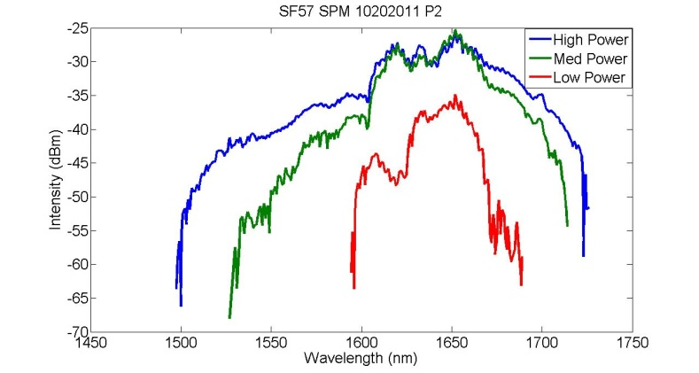This result shows notable broadening, and preliminary calculations of the nonlinearity can be derived from the broadening factor representative of nonlinear phase shift. Recently our collaborators in Adelaide have realized an interesting result utilizing a fiber of the same microstructure made from Bismuth Oxide glass, shown below.

Figure 7: These plots show a multitude of gained peaks due to various nonlinear scattering processes occurring in Bismuth oxide Hex WW fiber. The left plot shows outputs for various input powers of fs fiber-based pulsed laser at 1.56um and the plot on the right shows the output for 20 cm of the same fiber with the same pumping regime. The distinct peaks signature of four-wave mixing is apparent in these plots [15].

Figure 6: These plots show pronounced broadening due to self-phase modulation of 200fs long pulses in 10cm of SF57 Hex WW fiber at 1.645µm and 1.58µm pump wavelengths. The distinct peaks signature of four-wave mixing is not apparent in these plots.

The number and the distinctness of the peaks implies that the scattering is due to a multitude of possible nonlinear optical processes including raman shifting, soliton formation and fission leading to dispersive wave generation, four-wave mixing and third harmonic generation.

1. Research Plan

In order to address **specific aim #1**, we propose amplitude modulation of two continuous wave (CW) lasers; one tunable from 0.99um to 1.09um (T Optica DLpro) and the other tunable in the C band. The modulation mechanism will be a LiNbO3 based electro-optic modulation with fiber coupling. Pulses will then be amplified for adequate peak power.

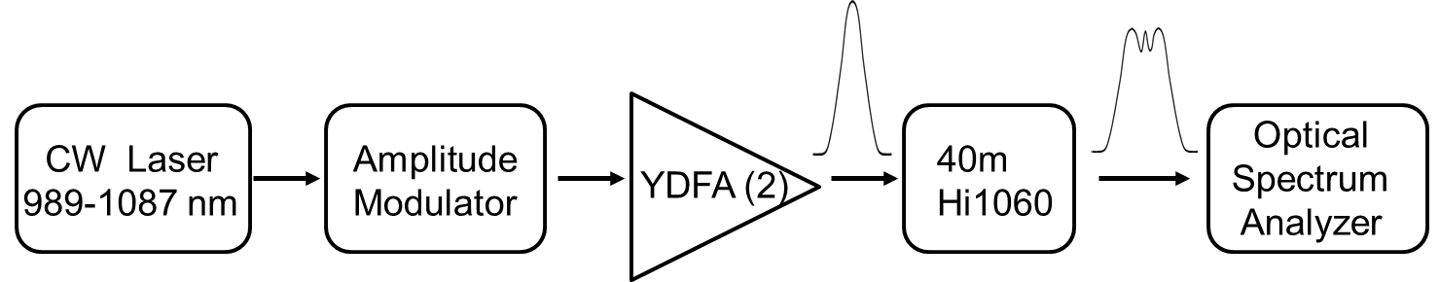The primary objective of this study will be to attain modulation that is fast enough to generate a train of ps long pulses that can subsequently be amplified while maintaining their shortness. Short pulses, high power are necessary to achieve  nonlinearities. We predict that pulse peak powers on the order of 1kW are sufficient to generate nonlinear effects, namely SPM, in 40m of standard solid core Hi1060 fiber.

Figure 8: Shown is a schematic of the proposed directly modulated tunable source. Continuous wave (CW) from a tunable diode laser is modulated and amplified through two (2) ytterbium doped amplifiers. Pulses generated from this modulation are then launched into 40m of step-index fiber that is single mode at 1.06µm. Broadening of pulses is then observed on an optical spectrum analyzer (OSA).

For **specific aim #2**, we propose to use the source developed in specific aim #1 to perform characterization of the soft-glass microstructure fibers. These characterizations include measurement of the dispersion, coupling efficiency and nonlinear phase shift [8]. This study will elucidate the parameters needed to generate phase-matched  parametric gain.

The dispersion measurement will be Fourier Transform Spectral Interferometry (FTSI), a common method for measuring dispersion in relatively short lengths of test fiber [9, 10]. The fiber is placed in one arm of a Michelson interferometer pumped by a tunable, pulsed source. The spectral interference between the fiber and free space is measured. The frequency of interferometric fringes varied with the input wavelength so a fourier transform of the fringe pattern as a function of wavelength reveals information about the relative delay between pulses from each arm. A calibration of the frequency shift with a known delay allows for a plot of delay vs. wavelength, a derivative of which yields the fiber’s group velocity dispersion (GVD) as a function of wavelength. For the SGMOFs we have, the C-band tunable source will be used in order to study the region around the predicted ZDW’s.

The coupling efficiency study in the SG MOF’s will aim to characterize the power in the fundamental mode of the fiber for several different coupling regimes. Proper coupling has been a challenge in preliminary study of these fibers. Here, no fewer than four aspheric lenses and no fewer than two fibers will be used to couple light into the SG MOF’s we are working with. Ensuring coupling into the fundamental mode will be studied by imaging the output of the test fiber. Historically, coupling into the core of the HWW fiber is indicated by a tightly confined image of the inner microstructure on this output. Assuming that most of the power is in the fundamental mode of the fiber when light is coupled into the core, we can measure fundamental mode coupling by measuring the output power. Efficiency will be measured as a percentage of input power that is transmitted when light is properly coupled into the core. A comparison of these efficiencies for different coupling mechanisms will indicate the best coupling method.

To achieve **specific aim #3** we propose to employ an appropriate soft glass microstructure fiber in a fiber optical parametric oscillator. An appropriate fiber will have a zero dispersion wavelength in region where pump lasers are available. The previous studies performed to address specific aims #1 and #2 will provide the necessary information to determine a suitable fiber. A fiber that exhibits well defined four-wave mixing utilizing the directly modulated tunable pump laser will be placed in a Fabry-Perot cavity to form a resonant oscillator. The result of this study will be a tunable coherent light source pumped by a practical pump laser. If it is determined that none of the available fibers are practical for efficient four-wave mixing, alternative application of the highly nonlinear behavior such as supercontinuum generation in these fibers will be explored further [16].

Timeline

|  |  |  |  |  |  |  |  |  |  |  |  |  |  |
| --- | --- | --- | --- | --- | --- | --- | --- | --- | --- | --- | --- | --- | --- |
|  |  | **Year 1** | |  |  | **Year 2** | |  |  | **Year 3** | |  |  |
|  |  | **Q1** | **Q2** | **Q3** | **Q4** | **Q1** | **Q2** | **Q3** | **Q4** | **Q1** | **Q2** | **Q3** | **Q4** |
|  |  |  |  |  |  |  |  |  |  |  |  |  |  |
| **Aim #1: Build a directly modulated tunable (DMT) source that can achieve a peak power sufficient for a FOPO device** | |  |  |  |  |  |  |  |  |  |  |  |  |
|  |  |  |  |  |  |  |  |  |  |  |  |  |  |
|  | *Modulate tunable CW lasers (1*µ*m, 1.6*µ*m) with fastest detectors available* |  |  |  |  |  |  |  |  |  |  |  |  |
|  |  |  |  |  |  |  |  |  |  |  |  |  |  |
|  | *Analyze pulse powers with nonlinear phase shift in single mode fiber* |  |  |  |  |  |  |  |  |  |  |  |  |
|  |  |  |  |  |  |  |  |  |  |  |  |  |  |
| **Aim #2: Perform fiber characterization experiments with directly modulated tunable Erbium-doped fiber laser** | |  |  |  |  |  |  |  |  |  |  |  |  |
|  |  |  |  |  |  |  |  |  |  |  |  |  |  |
|  | *Characterize the mode matching with various lenses/patch fibers for available fibers* |  |  |  |  |  |  |  |  |  |  |  |  |
|  |  |  |  |  |  |  |  |  |  |  |  |  |  |
|  | *Experimental dispersion measurements for available fibers* |  |  |  |  |  |  |  |  |  |  |  |  |
|  |  |  |  |  |  |  |  |  |  |  |  |  |  |
| **Aim #3: Attempt a FOPO with DMT source and two highly nonlinear optical fibers** | |  |  |  |  |  |  |  |  |  |  |  |  |
|  |  |  |  |  |  |  |  |  |  |  |  |  |  |
|  | *Produce phase matching curves for selected fibers* |  |  |  |  |  |  |  |  |  |  |  |  |
|  |  |  |  |  |  |  |  |  |  |  |  |  |  |
|  | *Experimentally demonstrate four-wave mixing in selected fibers* |  |  |  |  |  |  |  |  |  |  |  |  |
|  |  |  |  |  |  |  |  |  |  |  |  |  |  |
|  | *Experimentally demonstrate oscillator with selected fiber* |  |  |  |  |  |  |  |  |  |  |  |  |
|  |  |  |  |  |  |  |  |  |  |  |  |  |  |

References

1. P. A. Franken, A. E. Hill, C. W. Peters, and G. Weinreich, Phys. Rev. Lett. **7**, 4, 118-119 (1961)
2. G. P. Agrawal, Nonlinear Fiber Optics, 4th ed., Academic Press, San Diego, Calif., (2001).
3. Yaman et. al. Guided Wave Optical Components and Devices, chapter 7
4. P. Petropoulos, H. Ebendorff-Heidepriem, V. Finazzi, R.C. Moore, K. Frampton,

D.J. Richardson, T.M. Monro, Opt. Express, **11**, 26, 3568-3573 (2003)

1. W. Q. Zhang, S. Afshar V. and T. M. Monro, **17**, 21, 19311-19327 (2009)
2. W. Q. Zhang, H. Ebendorff-Heidepriem, T. M. Monro, and S. Afshar V., Opt. Express **19**, 21135-21144 (2011)
3. K. Saitoh and M. Koshiba, J. Lightwav. Technol. **23**, 11, 3580-3590 (2005)
4. R.H. Stolen, C. Lin, “Self-phase-modulation in silica optical fibers”, Physical Review A **17** (4) (1978)
5. C. Dorrer, N. Belabas, J.-P.Likforman, and M. Joffre, J. Opt. Soc. Am. B  **17,** 1795-1802 (2000)
6. T. Zhang, Z. Yang, W. Zhao, Y. Wang, P. Fang, and C. Li, Chin. Opt. Lett. **8**, 262-265 (2010)
7. J. E. Sharping, M. Fiorentino, A. Coker, P. Kumar, and R. S. Windeler Opt. Lett. **26**, 1048-1050 (2001)
8. Jay E. Sharping, Marco Fiorentino, Prem Kumar, and Robert S. Windeler, Opt. Lett. **27**, 1675-1677 (2002)
9. D. A. Akimov, E. E. Serebryannikov, A. M. Zheltikov, M. Schmitt, R. Maksimenka, W. Kiefer, K. V. Dukel’skii, V. S. Shevandin, and Yu. N. Kondrat’ev, Opt. Lett. **28**, 1948-1950 (2003)
10. J.E. Sharping,J. Lightwave Technol., **26**, 14, 2184-2191, (2008)
11. Figures obtained from correspondence between IPAS, Adelaide, Australia and Applied Photonics Research Group, Merced, CA.
12. J. M. Dudley, G. Genty, and S. Coen, Rev. Mod. Phys.**78**, 1135–1184 (2006)