Guidelines for writing your Physics thesis
by
Jay E. Sharping
A thesis submitted in partial fulfillment of the requirements for the degree of
Bachelor of Science in Physics
University of California Merced
2015

Advisor
Date

University of california Merced
Abstract

by
A paragraph that summarizes your thesis. This is the first thing someone reads, and sets the tone for the rest of the paper, and gives the reader an idea of where the story is going. You should include a brief summary of the problem statement, how you approached the problem experimentally/theoretically, and a quantitative summary of your main results.

Table of Contents
Contents
Table of Contents ii
List of figures iii
Acknowledgments iv
Chapter 1. Introduction 1
1 A clear scientific problem statement, question, or hypothesis 1
2 Motivation 1
3 Context & Relevance 1
4 Outline 2
5 How to create a new section 2
6 Heading 3 looks like this 2
7 How to Insert a Picture or Caption 3
Chapter 2. Background 4
8 Theoretical background: 4
Chapter 3. Methods 5
Chapter 4. Results and discussion 6
Chapter 5. Conclusion 8
9 Notes on style 8
10 A simple strategy for writing papers: 9
bibliography 10
Appendix 11

List of figures
Figure 1: this is a plot of stability location as a function of index contrast. 3

Acknowledgments
The author wishes to express sincere appreciation to Professors …

Introduction

A clear scientific problem statement, question, or hypothesis
Your first goal in the introduction should be to get to the problem statement as soon as it is practical, so the reader understands up front where the story is going. For the reader to understand the problem statement usually requires some context, background and/or motivation first (discussed separately below); how much of each depends a lot on the particular problem. A problem statement in the first paragraph can be helpful to focus the reader on the main story, but it may require some elaboration near the end of the introduction after more context and background information has been given. The order of the different parts of the introduction may vary if it helps the story flow better.

Motivation
You need to get your reader interested in your research if you want them to read your paper. The motivation may be purely scientific in nature, or there may be practical applications, or both.

Context & Relevance
You should include information about previous work in the field, with references. The point of this is to put your research in the context of other scientific research that has gone on. If you are going to compare to prediction(s), explain the prediction(s) here. If other groups have made similar measurements, you should briefly summarize their results.
Next, you should make a case for why your work will add to the body of scientific knowledge. For example, how does your work go beyond previous work, such as measuring something new, more accurately, or over a wider parameter range? For this reason, when summarizing previous work, it may be helpful to highlight what they did differently than you. It may also be helpful to explain if you are using a different technique that has some capability that earlier attempts did not have.

Outline
The introduction should end with a short paragraph that is an outline of the rest of the paper, i.e. what will be covered in each of the following sections. It is more informative to be specific: for example, don't just say that you will describe results in the results section. For example, you could write "In Section 3, I will present measurements of the period of a pendulum and fit equation 1 to determine g." This is a good opportunity to explain where the story is going so the reader doesn't get lost; don't be afraid to give away the conclusions up front.

How to create a new section
Type in your section title and select “Heading 3” from the styles menu. Note that you can create subheadings using “Heading 4”, “Heading 5”, …

Heading 3 looks like this

Heading 4 looks like this

Heading 5 looks like this

Note however that “Heading 2” is reserved for chapters and “Heading 1” is reserved for other document components. DON’T USE “Heading 1”

How to Insert a Picture or Caption
On the Insert menu, point to Picture, and then click the command that corresponds to the type of element you want to insert. To add a caption, right click on the picture and choose “insert caption”, and then start typing. You can always change the caption content later.
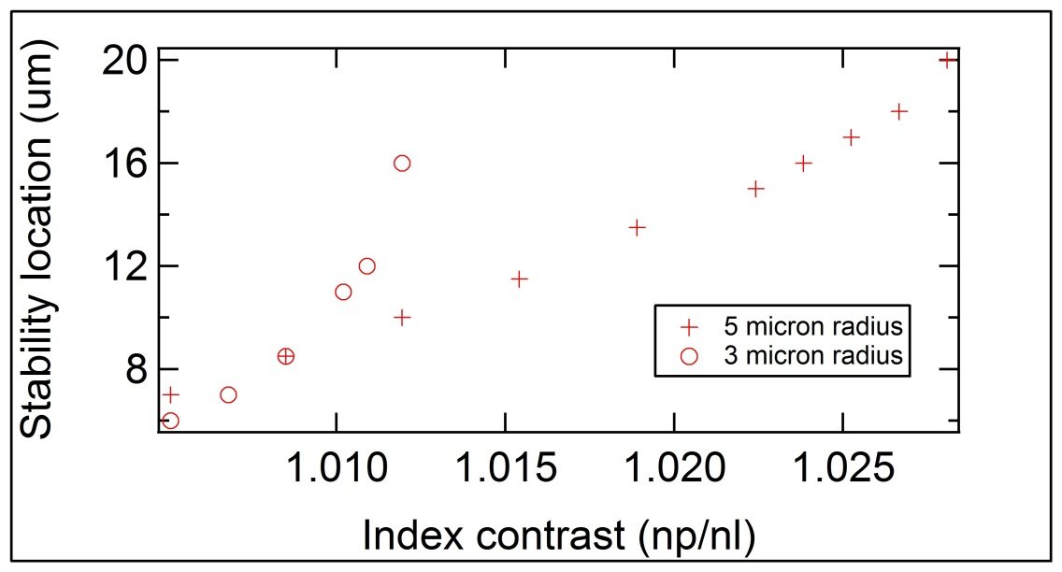
Figure 1: this is a plot of stability location as a function of index contrast.
Creating a new chapter is as easy as typing the chapter number and name and selecting “heading 2” in the style menu.

Creating the list of figures
Under the section in the front matter, select the “References” tab and then choose “Insert Table of Figures”. I think that this will update automatically when you print your document, but I’m not 100% sure. Double check.

Background

Theoretical background:
You will likely need to provide some theoretical background. For example, if your goal is to test the validity of an equation, that equation should be given in the introduction. You should show and reference the relevant equations that are used to calculate results or compare to later, and explain qualitatively how they will be used. You do not need to show equations that will not be referred later in your paper. The challenge is to provide just enough information for the reader to understand the scientific significance of your problem statement and what you are doing, without overwhelming the reader with information.

Methods
Methods: A chapter that explains how you actually made the measurement. The description of your measurements/calculations should include enough detail so that someone could reproduce them. You should assume the person trying to reproduce measurements/calculations works in a different lab with different equipment and software, so describe equipment/software by relevant properties such as "a multimeter with resolution 0.01 V", rather than "the orange multimeter". Diagrams are useful for explaining your setup. Be sure to identify which quantities you are measuring/calculating and how. Give values for all relevant dimensions and other physical properties, with uncertainties (hint: if a parameter shows up in an equation, it is relevant). When identifying uncertainties, it may be important to specify whether they are systematic or random, if that will affect your conclusions. You may need to explain why some components of an apparatus are important.

Results and discussion
Results: The results section should be focused on presenting plots of your data/calculations with error bars, labeled axes, and units. Be sure to explain what is plotted and what conclusions can be drawn from each plot. Some plots are meant to show examples of the system response; in that case explain what the features of the plot correspond to physically. Often, important conclusions can be made by comparing data and theory -- show these comparisons on the same plot so the comparison can be seen easily. Don't forget to include results of calibration runs or other control experiments. This section should also include the results of any calculations, data analysis, fits, and propagation of uncertainties.
Figure captions: Figures should have captions that explain what is shown. Since a lot of readers will look at figures out of order from the main text, it is usually helpful to assume the reader hasn't read the main text and briefly repeat the relevant description from the main text.
Discussion: Generally, results require some discussion to explain the physical significance of your results and how you logically reach conclusions. Here you should quantitatively compare your results to any existing theory, hypotheses, known values, or sanity checks (with references). For example, is your measurement consistent with a theoretical value within the measured uncertainty? If it is relevant to your conclusions, include a discussion of how any approximations you made influenced your results. Be quantitative if possible, for example, could you put an upper bound on the error introduced from any approximations? If your work is purely theoretical, you should address how your results could be tested by experiment or simulation.
The best place to put the discussion may vary. Sometimes, a point can be made from a single plot, and it makes sense to include that discussion right after you explain the plot. Other times, a point requires supporting information from several plots. In the latter case, it might make more sense to include a separate discussion section after the results, but before the conclusions. Consider how the story flows best to decide whether you want to include discussion in the results section, after it, or have a mix of the two.

Conclusion
A summary of your conclusions which follow from your main results. These conclusions should be quantitative, include uncertainties, and follow logically from the plots in your results section. You can and should repeat important quantitative results from the results section. The conclusions should address the problem statement (if it doesn't, you should probably revise your problem statement; revising hypotheses based on results is part of the scientific method).
Finally, if appropriate, address any open questions. For example, if you did not get the expected results, could any of your observations or approximation possibly explain the discrepancy? Be specific: noting that a discrepancy increases under certain experimental conditions is important, on the other hand attributing discrepancies to human error or equipment malfunction is not informative. What experiments/calculations could be performed in the future to resolve these issues? Sometimes, results may even suggest new experiments to be done or theoretical problems to address; mention these here.

Notes on style
The sections mentioned above are a good start, and further subsections are highly recommended. For example, separate subsections for different types of results can be helpful. You can then refer to different sections or subsections by number throughout the paper. -Writing style should be technical, clear, and concise like a good article in a physics journal (see for example, Physical Review A-E). That doesn't mean the writing should be dry and hard to read. The writing should flow well and present a clear story where the introduction introduces a problem, the methods and results develop it, and the conclusion resolves it. A good rule of thumb is to ask yourself if a section of text helps the reader better understand the problem, methods, results, or conclusions; if the answer is no, remove the text. -Know your audience. For an audience of physics students and faculty, you can assume the audience has a knowledge of lower division physics courses. One most common mistake is to use the specialized jargon of your field or research group without defining the terms when they are introduced. You should think about how to explain the important parts of your work to a non-specialist.

A simple strategy for writing papers:
Start with your data plots, and put any relevant fits or theoretical equations on them for comparisons. The results section should be fleshed out by explaining what is in each plot and how to interpret them. Next, decide what conclusions you can draw from the plots. The entire report will be focused around these plots and conclusions. Even though the conclusion is at the end of the report, it can help to write it first to give you a target to write for. The rest of the report should be written to lead up to your plots and conclusions, and contain only the information needed to get the reader to understand them. You can now write a problem statement that leads into the conclusions. It is okay if it is different than the problem statement you had in mind when you started the experiment; refining hypotheses based on data is part of the scientific process.

bibliography
References should be formatted in the style of a physics journal of your choice; they must include names of authors and enough information to find the reference.

Appendix
Sometimes you may want to include detailed calculations or additional data to support your arguments, but it would interrupt the flow of the story to include it in the main text. Consider putting these items separately in appendices. When you need these results to support an argument in the main text, you can make a reference to the appropriate appendix.

